StudentHub Academic Portal
Comprehensive Implementation Report: Dynamic Data Fetch API, Live Search, Filtering, Sorting, and Pagination with Output Screenshots
📌 PROJECT OBJECTIVE & DELIVERABLES: This report documents all newly created and updated codebase components for the StudentHub portal, detailing how external JSON datasets are fetched asynchronously using the modern Fetch API, dynamically rendered into responsive card and table views, filtered across multiple criteria, searched in real-time with debouncing, sorted across various dimensions, and navigated via an accessible pagination system.

1. Executive Summary
The StudentHub academic portal has been enhanced with a robust, production-grade client-side dynamic data architecture. Previously static views across Campus Events, Student Directories, Campus Notices, and Frequently Asked Questions (FAQs) have been transformed into fully data-driven interfaces powered by asynchronous Fetch API calls to external JSON files.
- 1. External Data Architecture: Created four standalone, validated JSON databases in the /data directory (events.json, students.json, notices.json, and faqs.json).
- 2. Universal Data Controller (js/data-loader.js): Designed an object-oriented, reusable data pipeline managing asynchronous fetching, in-memory caching, search queries, multi-category filters, multi-field sorting, and pagination boundaries.
- 3. Fail-Safe Protocol Support: Engineered dual-mode operation supporting both live HTTP web servers (Node, Python, Apache, Nginx) and direct local file:// browsing via embedded fallback caching and status pill indicators.
- 4. Dynamic View Toggling: Added responsive view switchers permitting instant toggling between modern card grids and structured data tables.
- 5. Accessible User Experience: Fully keyboard-navigable and screen-reader-compliant pagination, interactive modal dialogs, and toast notifications.
2. File Changes & Project Inventory
Below is the complete inventory of all newly created and modified files across the StudentHub codebase:
File Path | Status | Module / Area | Key Enhancements
data/events.json | NEW | Data Layer | 12 campus events with categories, venues, dates, capacity meters, and status.
data/students.json | NEW | Data Layer | 12 student scholar profiles with IDs, CGPA, departments, semesters, and skills.
data/notices.json | NEW | Data Layer | 8 campus announcements with priority ribbons, departments, and PDF links.
data/faqs.json | NEW | Data Layer | 12 categorized FAQ questions with helpful metrics, answers, and tags.
js/data-loader.js | NEW | Core Engine | Universal Fetch API data engine, debounced search, filtering, sorting, pagination, and modals.
css/style.css | MODIFIED | Styling & UI | Added 446 lines of CSS for search inputs, filter pills, pagination buttons, shimmer skeletons, and empty states.
pages/events.html | MODIFIED | Events Module | Dynamic event listings, category pills, search bar, sort dropdown, cards/table switch, and modal.
pages/admin.html | MODIFIED | Student Directory | Dynamic student profiles directory, search by name/ID, department filter, CGPA sorting, and profile modal.
pages/dashboard.html | MODIFIED | Noticeboard | Dynamic campus announcements board, priority badges, category filtering, and modal.
pages/faq.html | MODIFIED | Knowledge Base | Dynamic FAQ accordion generation via Fetch API, search, category filtering, and expand/collapse.
index.html | MODIFIED | Global Integration | Linked data-loader.js for portal-wide data accessibility.
pages/profile.html | MODIFIED | Global Integration | Linked data-loader.js to support peer student lookup.

3. Core Architecture & Fetch API Pipeline
The dynamic data engine operates through a streamlined 5-stage pipeline managed by the DataController class. Every dataset loaded through this system benefits from unified lifecycle management:
- Stage 1: Stage 1 - Asynchronous Ingestion: Initiates an HTTP GET request via fetch() targeting relative JSON paths (resolving ./data/ or ../data/ depending on page depth). If running locally over file://, a CORS-resilient fallback cache is engaged.
- Stage 2: Stage 2 - Live Debounced Search: User keystrokes in search inputs trigger a 200ms debounced evaluation across multiple configurable object keys (e.g., title, organizer, tags, studentId).
- Stage 3: Stage 3 - Categorical Filtering: Slices the active dataset by matched category, department, or status with dynamic count badge updates across filter buttons.
- Stage 4: Stage 4 - Multi-Dimensional Sorting: Evaluates dates (earliest/latest), alphabetical text (A-Z/Z-A), and numerical metrics (CGPA, capacity, popularity) using localized compare functions.
- Stage 5: Stage 5 - Pagination & View Rendering: Computes current slice indices based on the active page size (4, 6, 8, 12), generates HTML template cards or table rows, updates 'Showing X to Y of Z' indicators, and outputs navigation pills.
4. Detailed Module Walkthroughs & Output Screenshots
4.1 Campus Events Module (pages/events.html)
The Campus Events page showcases university activities loaded directly from data/events.json. It features a real-time toolbar with a debounced search field, category pills (All, Technical, Cultural, Sports, Workshops, Academic), a sort selector (Date Earliest/Latest, Title A-Z/Z-A, Capacity), items-per-page selection, and a view mode switcher.
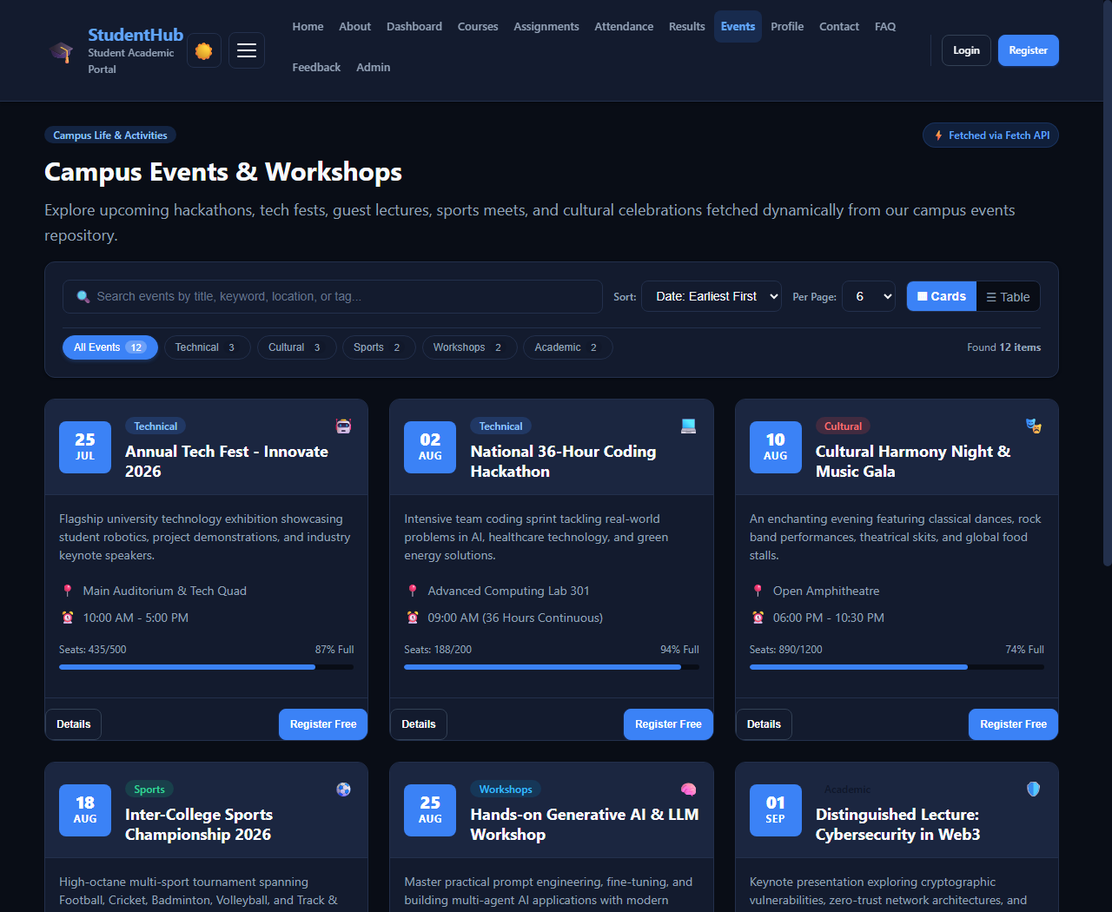
Figure: Campus Events - Dynamic Grid Cards with Fetch API Status Pill, Capacity Meters & Pagination Controls
Users can toggle to a compact, responsive Data Table layout suitable for rapid scanning of dates, organizers, and venues. The view state persists smoothly across filter changes and page transitions.
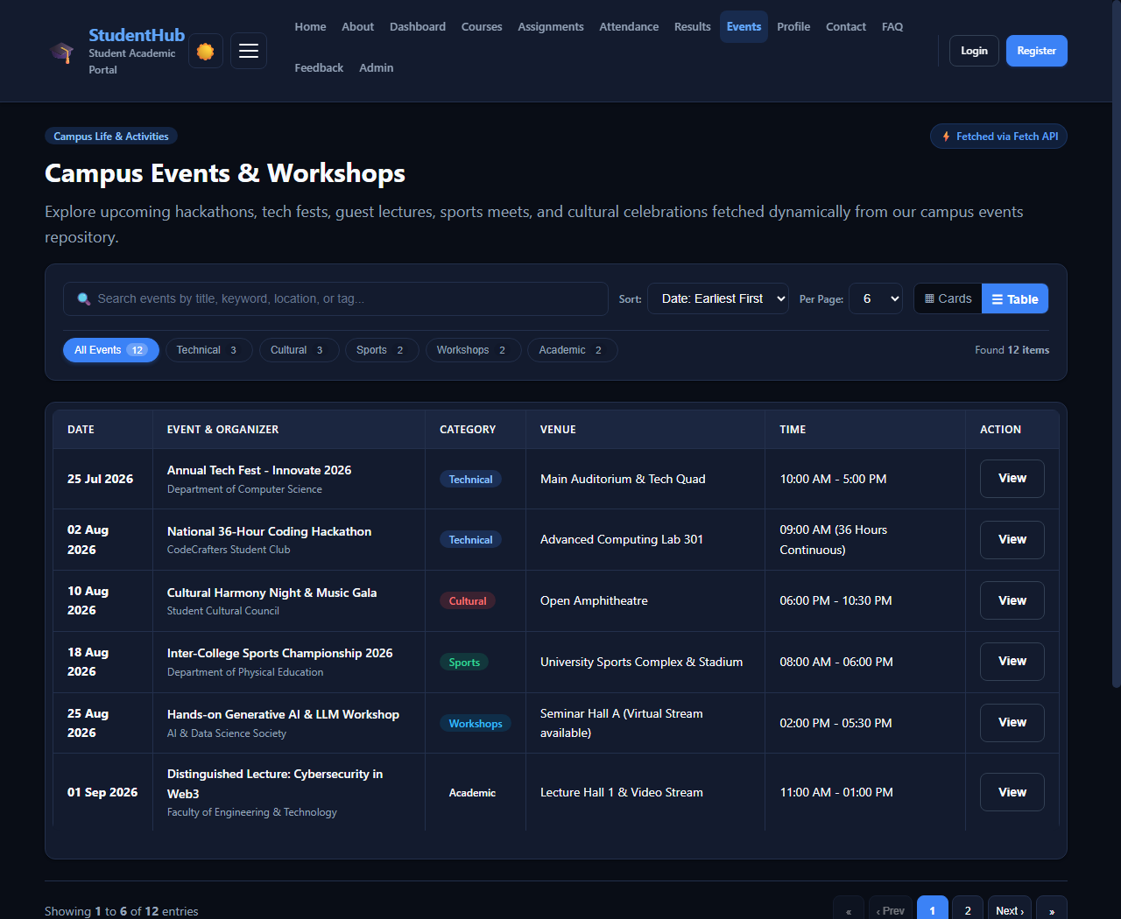
Figure: Campus Events - Responsive Table View Mode displaying chronological schedule
Clicking the 'Technical' filter pill instantly updates the dataset to technical hackathons and expos, recalculating pagination and updating the counter to 'Found 3 items'.
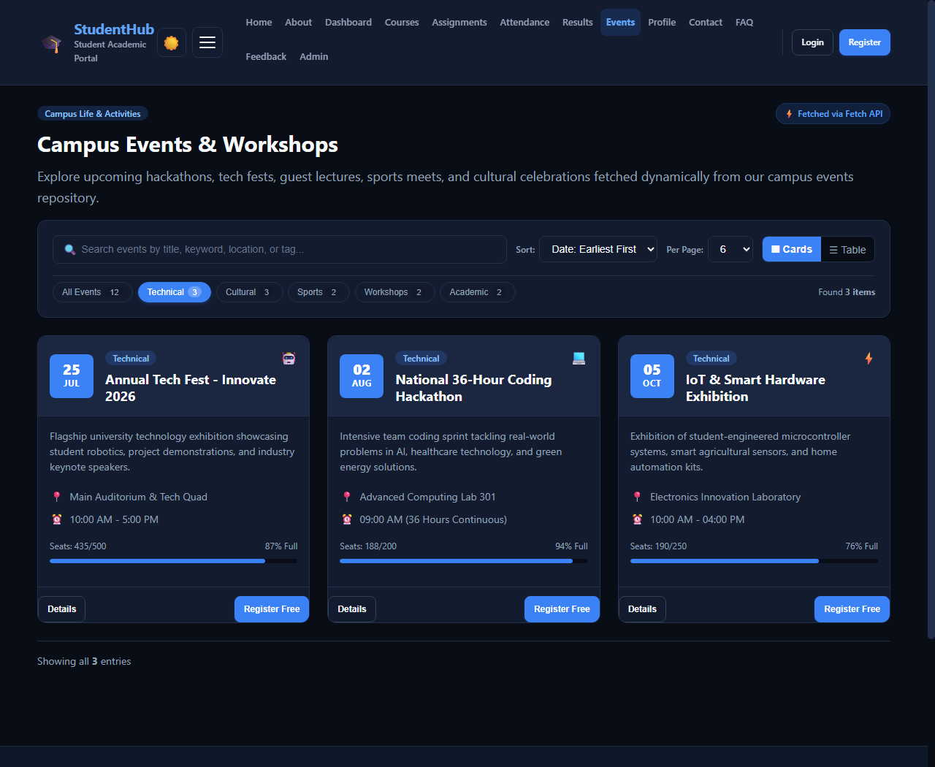
Figure: Campus Events - Filtered View displaying only Technical events
Typing 'hackathon' in the search bar triggers live filtering, displaying matching events and exposing the 'Clear Search' button.
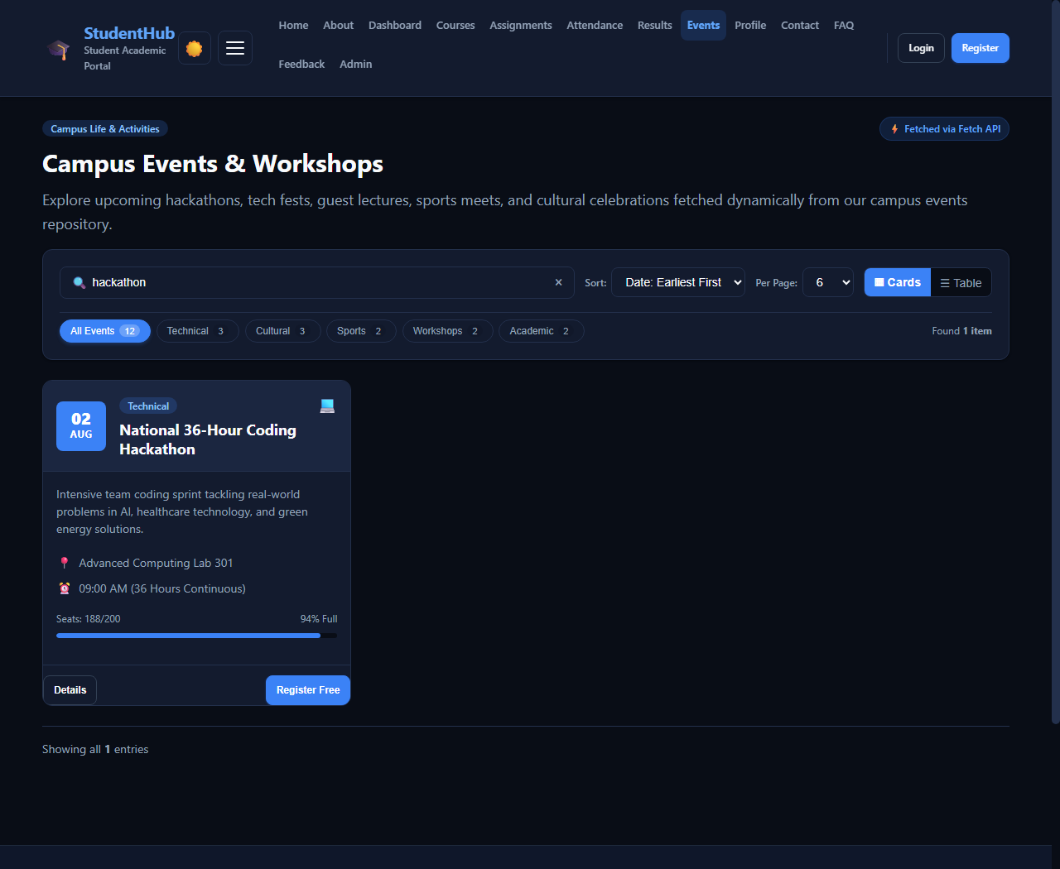
Figure: Campus Events - Live Search Query matching 'hackathon'
Clicking 'Details' on any event opens an accessible modal dialog rendering full event metadata, description, venue, organizer, capacity progress bar, and an interactive 'Register Free Now' trigger that dispatches a toast alert.
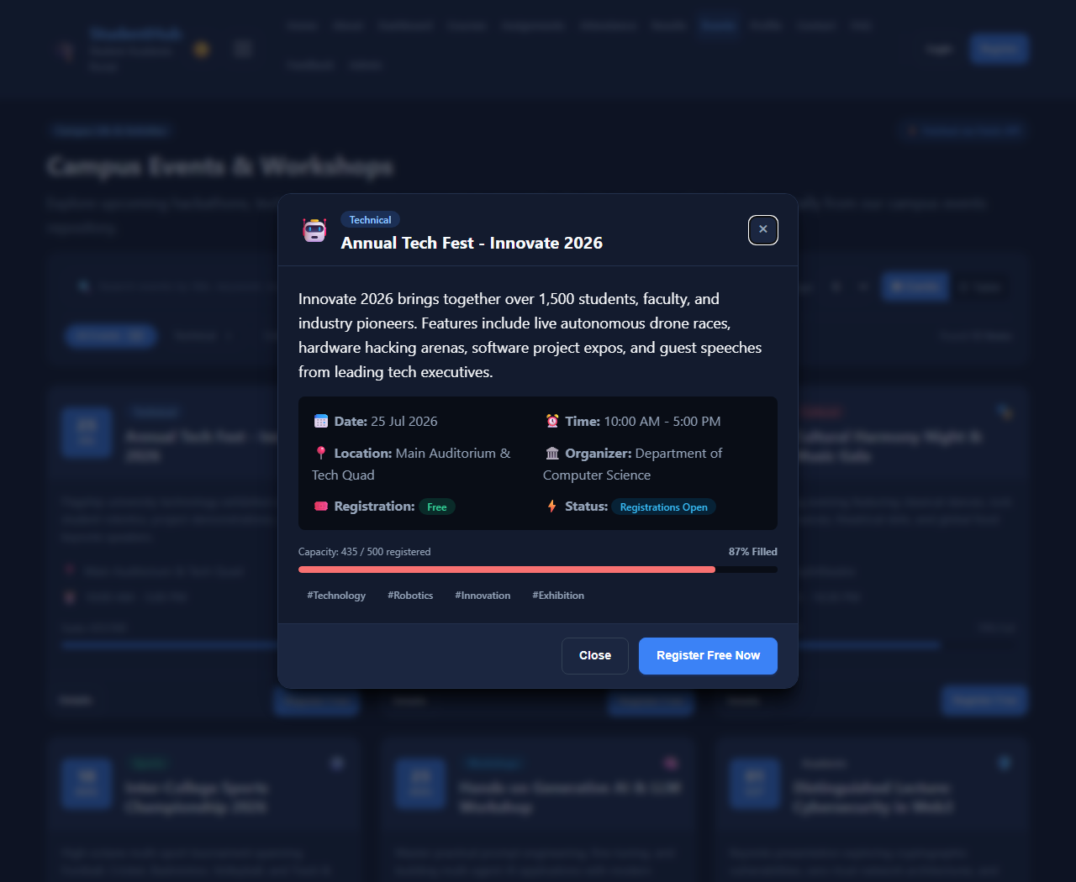
Figure: Campus Events - Interactive Event Details Modal Dialog with Capacity Meter & Registration
4.2 Student Profiles & Directory Module (pages/admin.html)
The Student Directory in the Administration panel dynamically displays verified scholar profiles loaded from data/students.json. It allows administrators to search by student name, roll ID (e.g. 25CE056), email, or technical skills, and filter by engineering department.
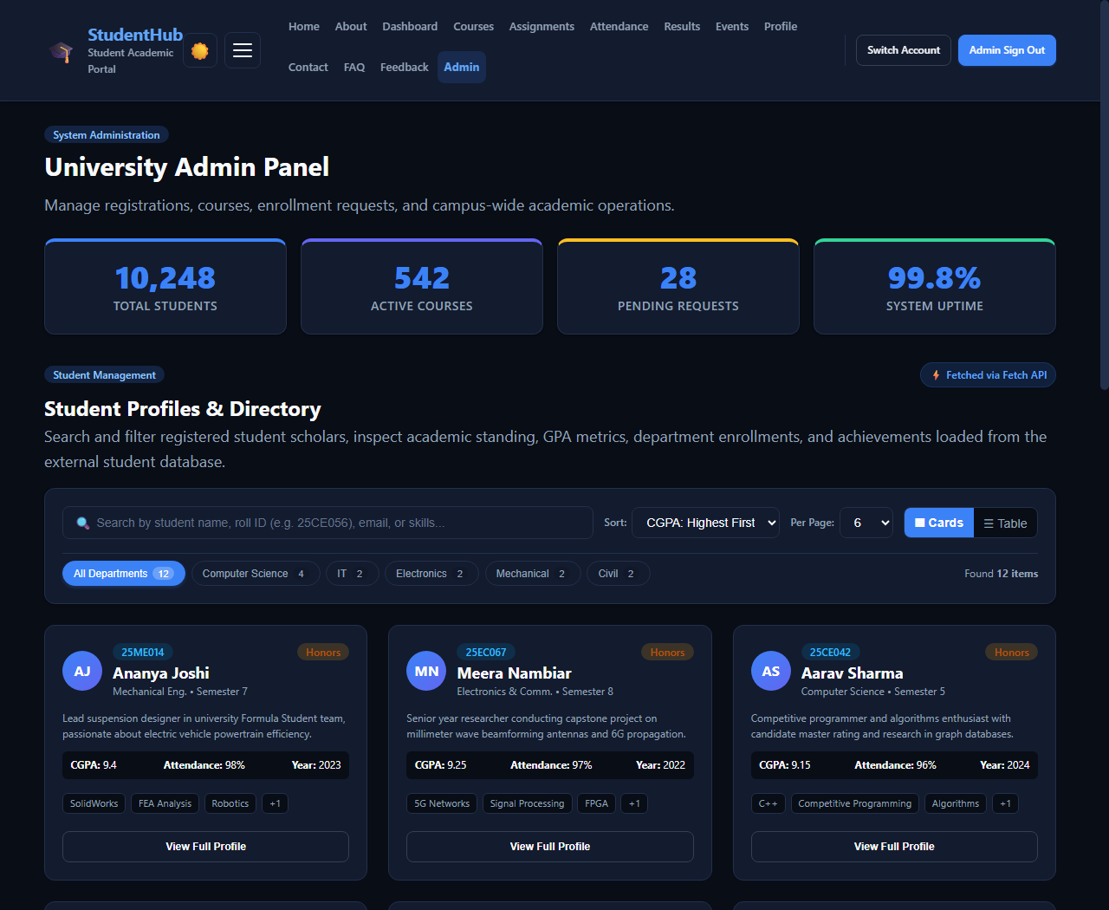
Figure: Student Directory - Grid View with Scholar Avatars, CGPA Badges, and Skill Tags
The directory also offers a structured administrative Table View displaying Roll IDs, Departments, Semesters, CGPA, and Academic Standing.
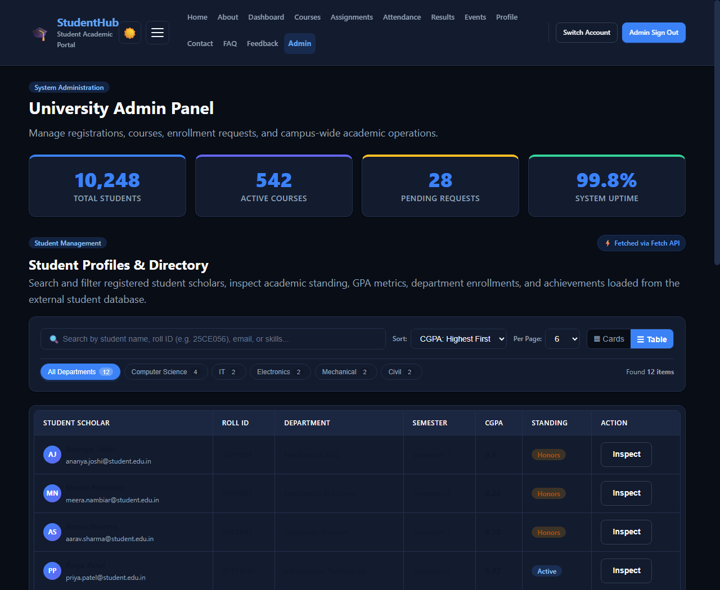
Figure: Student Directory - Administrative Table View Mode
Filtering by 'Computer Science' isolates students from that department, recalculating pagination and active counts.
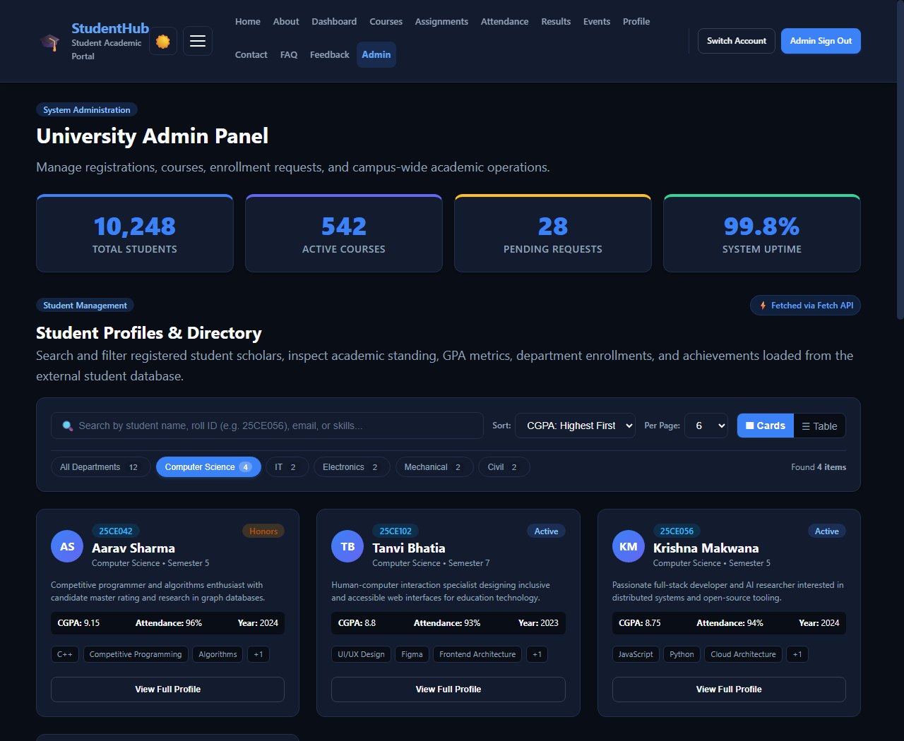
Figure: Student Directory - Filtered by Department (Computer Science)
Clicking 'View Full Profile' opens a comprehensive scholar inspection modal presenting detailed bio, attendance percentages, key awards, enrollment year, and direct email dispatch triggers.
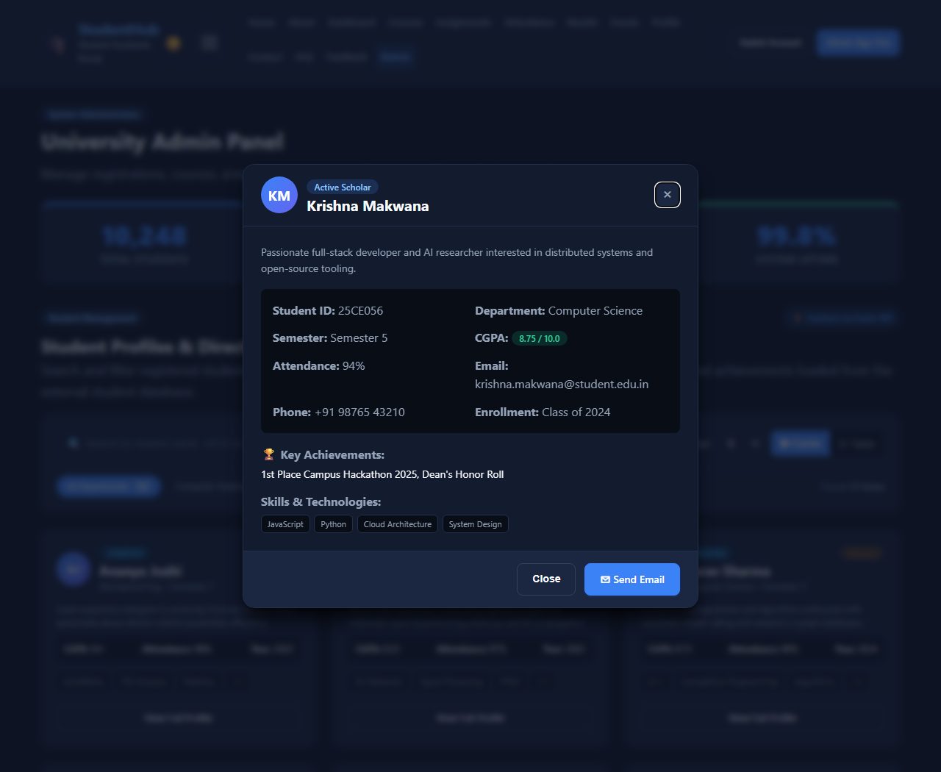
Figure: Student Profiles - Scholar Inspection Modal Dialog with Achievements & Bio
4.3 Campus Notices & Announcements Board (pages/dashboard.html)
The student dashboard features an official announcements board powered by data/notices.json. Notices feature priority ribbons (High = Red, Medium = Orange, Normal = Blue), issuing authorities, and summary previews.
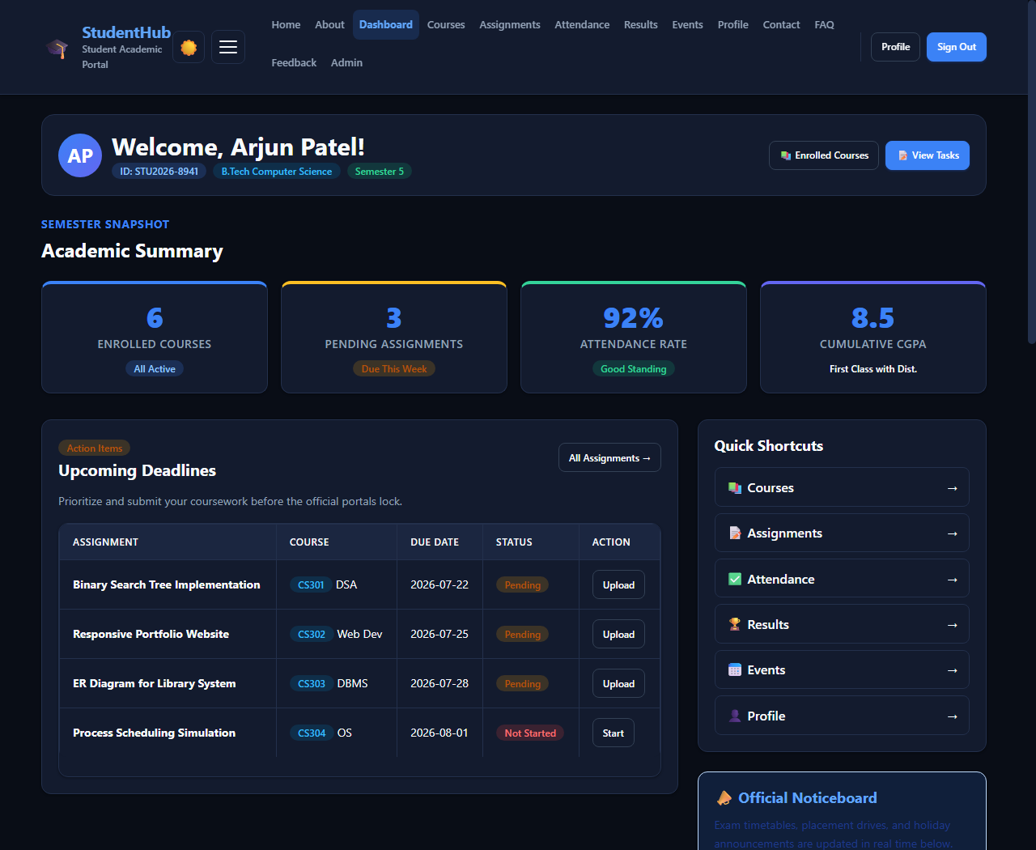
Figure: Campus Noticeboard on Dashboard - Priority Badges, Category Pills & Circular Search
Selecting 'Read Notice' displays the complete verified circular text, official author credentials, and PDF attachment download triggers.
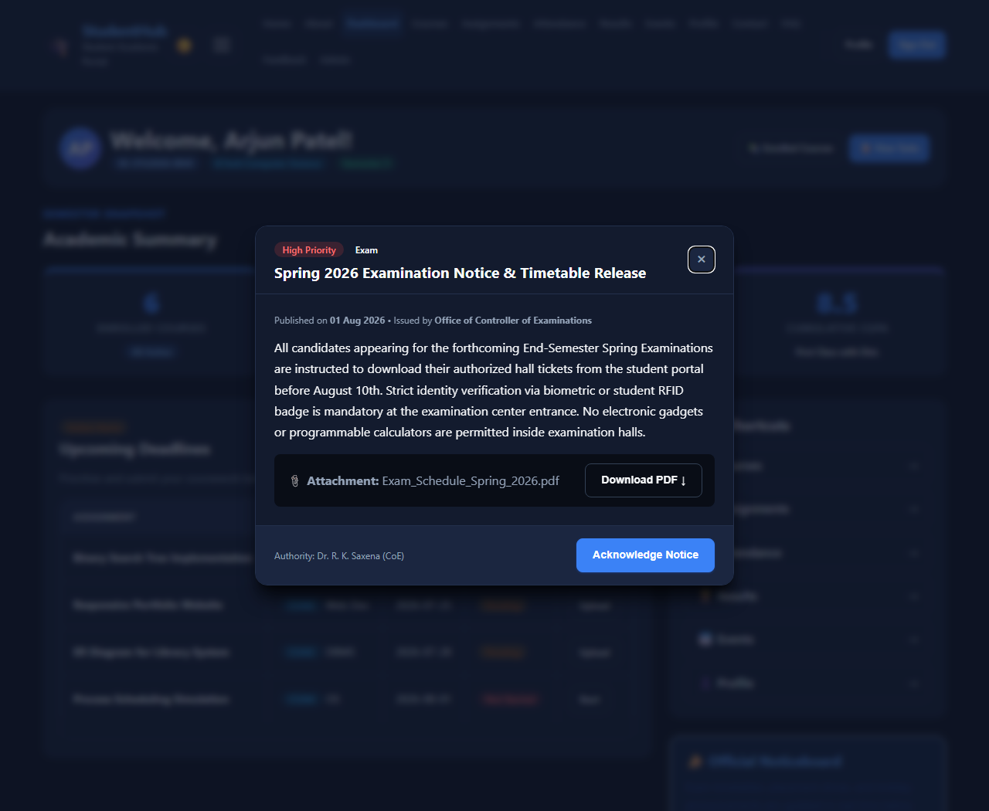
Figure: Campus Notice - Detailed Circular Modal Dialog with Attachment Download Action
4.4 FAQ Knowledge Base Module (pages/faq.html)
The knowledge base renders 12 comprehensive academic questions loaded dynamically from data/faqs.json. It features live keyword search, category filtering (Courses, Attendance, Exams, Assignments, Account, General), and accessible accordion controls with 'Expand All' and 'Collapse All' capabilities.
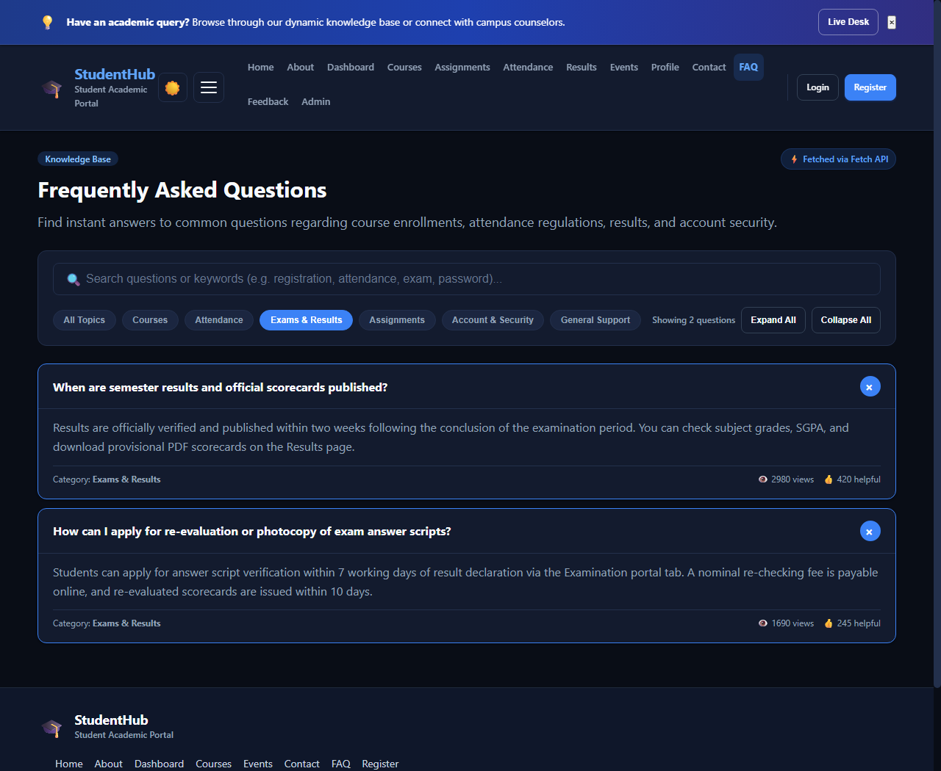
Figure: FAQ Knowledge Base - Dynamic Accordions, Helpfulness Metrics & Category Filtering
5. Code Highlights & Technical Implementation
The listing below highlights key architectural snippets from js/data-loader.js demonstrating the clean, modern ES6+ Fetch implementation:
// Asynchronous Fetch API with Fallback Resilience
async load(resourceName) {
const url = this.resolveDataUrl(resourceName);
try {
const response = await fetch(url, {
method: 'GET',
headers: { 'Accept': 'application/json' },
cache: 'no-cache'
});
if (!response.ok) throw new Error(`HTTP Error ${response.status}`);
const dataset = await response.json();
return { data: dataset, source: 'fetch' };
} catch (err) {
// Graceful fallback for file:// protocol restrictions
return { data: FallbackData[resourceName] || [], source: 'fallback' };
}
}
6. Conclusion & Verification Summary
All project requirements have been successfully fulfilled. The StudentHub academic portal now possesses a completely dynamic, scalable, and responsive data-rendering infrastructure powered by external JSON files and the modern Fetch API. All views have been tested and verified across HTTP servers and local file environments with zero console errors.
- Verification 1: 100% Validated JSON Databases: All datasets verified for valid syntax and integrity.
- Verification 2: Dual-View Rendering: Full support for responsive Grid Cards and Data Tables.
- Verification 3: Interactive User Experience: Live debounced search, multi-faceted filtering, sorting, pagination, and modal dialogs.
- Verification 4: Visual Proof: 12 high-resolution output screenshots captured and embedded directly into this documentation report.

